FIELD-TRIP to JPL Fri 4/29/11  Jet Propulsion Laboratory  Hosted by Dr. Tom Farr – ERTH-105” NASA Missions” Instructor  MUST SIGN UP IN ADVANCE!!!  Spots available on a first come basis - $30 per student.  Priority given to ERTH-105, ERTH-101H, and SBCC Astro Club.  If you are in the ERTH-105 “NASA Missions” you must sign up with the instructor (in class or by email). If you are not in ERTH-105 email your name, country of citizenship, and class you are taking to Erin at oconnor@sbcc.edu. If you are not a US citizen, you can still go (just need to know). Be sure to bring your drivers license on the trip (for ID purposes - Non-US Citizens must bring passport and/or Green Card).  Bus meets in front of the SBCC bookstore (at EBS Loading Dock). Trip leaves at 8 am sharp (please arrive early). Trip returns at approximately 5-6 pm (depending on traffic). We will eat at the JPL Cafeteria for lunch (bring money and/or your own sack lunch).  Dr. Tom Farr is a research scientist at JPL directly involved with current planetary missions at the Earth & Space Sciences Division of the Jet Propulsion Lab in Pasadena, CA. Click here to view info on Dr. Tom Farr's professional interests and background. To learn of current JPL space missions, click here to link directly to JPL's web site.  For more information: Erin O'Connor 965-0581 x4723  (www.fieldstudy.com, or at oconnor@sbcc.edu) | 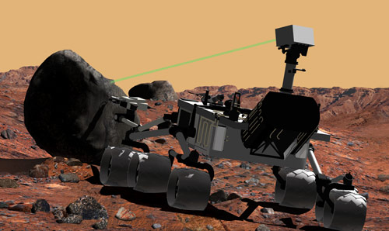
 | 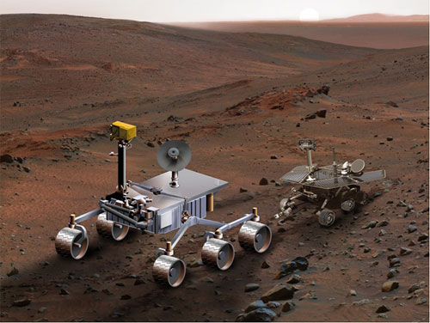
 | 